SERVICE CATALOG

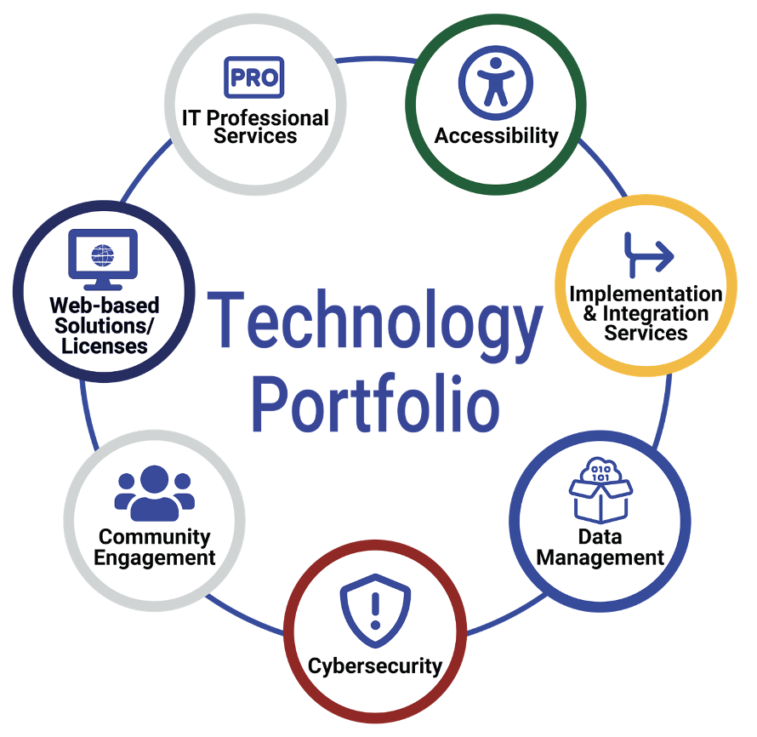
SIPA negotiates contracts with suppliers to offer vetted, secure technologies for high value vs. price and a simple procurement process for state and local governments in Colorado. Learn more at sipa.colorado.gov/services.

Accessibility
Assessments
Document Compliance
Website Platform Compliance
Training
Audits

Implementation & Integration Services
Google
Microsoft
Salesforce
Tableau &
Many others……

Data Management Cybersecurity
Analytics Assessments
Architecture Endpoint Device Management
Management Identity Management
Security Testing
Strategy Training
Storage
Visualization Community Engagement
Governance Agenda Management
Database Community Campaigns
Digital Communications
Web-based Solutions/Licenses Video Streaming
Payment Processing
Short-Term Rental IT Professionals Services
Public Records Application Development
Form Creation Change Management
Websites Strategic Planning
Google Suite Cloud Transformation
Microsoft Suite Custom Applications
Encryption Customer Experience
Customer Relationship Management Digital Strategy
Connect API-led Automation Digital Transformation
Business Intelligence Grant/Case Management
Call Center IT Consulting
eSignature Process Automation
Survey Tool/Experience Management Service Center/Help Desk
Project Management

